# C2- S4-PRACTICE

*NOTE: check your* ***THEORY slides*** *to answer those questions!*

# EXERCISE 1 – BOOK & AUTHORS

We want to manage books and authors:

* A book has always 1 author and only 1
* An author could write zero or many books.

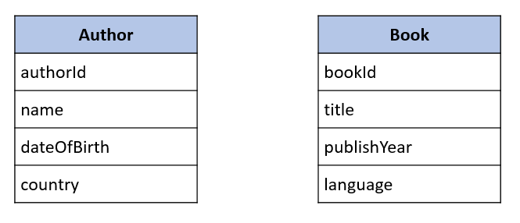

**Q1** – What is the relation between Book and Author tables?

The relation between Book and Author tables is one to many because

* one author can write many books.
* A book is written by one author.
* That is why relation between book and author is one to many.
  + Complete the missing field or table to allow this relation

one

many

|  |
| --- |
| **Author** |
| authorId  Name  DateofBirth  Country |

|  |
| --- |
| **Book** |
| bookId  title  publishYear  language  authorId |

**Q2** – For each table, complete the following arrays, by specifying for each field:

* + The field type (SQL type) and size
  + Can be null or not?
  + Is a primary key or foreign keys?

|  |  |  |
| --- | --- | --- |
| **Author** | | |
| PK | authorId  Name  DateofBirth  Country | int(10) auto_increment not null  varchar (100)  date  varchar (100) |

|  |  |  |
| --- | --- | --- |
| **Book** | | |
| PK  FK | bookId  title  publishYear  language  authorID | int(10) auto_increment not null  varchar (100)  date  varchar (100)  int (100) |

**AUTHOR TABLE**

|  |  |  |  |
| --- | --- | --- | --- |
| Field | Type / size | Null? | Key |
| authorId | Int(10) | no | PRI |
| Name | Varchar(100) | no |  |
| DateofBirth | Date | yes |  |
| Country | Varchar(100) | yes |  |

**BOOK TABLE**

|  |  |  |  |
| --- | --- | --- | --- |
| Field | Type / size | Null? | Key |
| bookId | Int(10) | no | PRI |
| title | Varchar(100) | yes |  |
| publishYear | date | no |  |
| language | Varchar(100) | yes |  |
| authorID | Int(100) | no | MUL |

**Q3** – Write the SQL statement to create the 2 tables with appropriate properties

create table Author (

    authorId int(10) auto_increment not null primary key,

    name varchar (100) not null,

    dateofbirth date,

    country varchar(100)

)

create table Book(

    bookId int(10) auto_increment primary key,

    title varchar(100),

    publishYear date not null,

    language varchar(100),

    authorId int,

    foreign key (authorId) references Author(authorId)

);

**Q4–** Write the statement to insert 5 books and 5 authors

* + Find the book and author information on internet

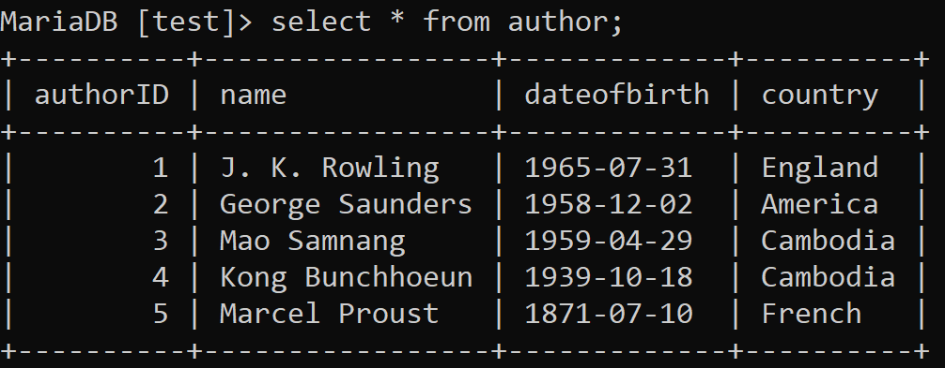

|  |  |  |  |  |  |
| --- | --- | --- | --- | --- | --- |
| bookId | | title | publishYear | Language | AuthorId |
| 1  2  3  4  5 | Teuk Ler Sleuk Chhouk  Harry potter  In search of lost time  Tenth of December  Troubled blood | 2008  1997  1913  2013  2020 | Khmer  English  English  English  English | 3  1  5  2  1 |

**Q5–** Write the SQL statement to **delete 3 of your books** from the database

delete from book where authorId = 1;

delete from book where bookId = 3 ;

EXERCISE 2 – USERS & POSTS

We want to manage **users** and **posts (**like posts on Facebook)

* A post is related to **1 user only**
  + A post has a body (the text of the post)
* User can have **many posts**
  + A user has a first name, and a nick name (optional)

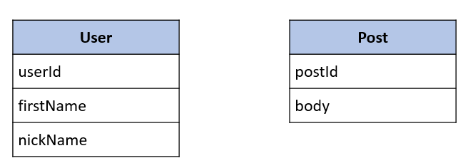

**Q1** – What is the relation between User and Post Table?

|  |
| --- |
| **Post** |
| postId  body  userId |

The relation between User and Post Table is one to many because one user can post many posts.

|  |
| --- |
| **User** |
| usesrId  name  nickname |

**Q2** – For each table, complete the following arrays, by specifying for each field:

* + The field type (SQL type) and size
  + Can be null or not?
  + Is a primary key or foreign keys?

**USER TABLE**

|  |  |  |  |
| --- | --- | --- | --- |
| Field | Type / size | Null? | Key |
| userId | Int(20) | No | PRI |
| name | Varchar(100) | No |  |
| nickname | Varchar(100) | Yes |  |

**POST TABLE**

|  |  |  |  |
| --- | --- | --- | --- |
| Field | Type / size | Null? | Key |
| postId | Int (20) | No | PRI |
| Body | Varchar(100) | No |  |
| userId | Int(20) | No | MUL |

**Q3** – Write the SQL statement to create the 2 tables with appropriate properties

Create table user (

    userId int(20) auto_increment not null,

    name varchar(100) not null,

    nickname varchar(100),

    primary key (userId)

);

Create table post (

    postId int(20) auto_increment primary key,

    body varchar(100) not null,

    userId int(20),

    primary key (postId),

    foreign key (userId) references user(userId)

);

**Q4–** Write the statement to insert the following users and posts

Notes:

* ---- means: no value
* We don’t specify the KEY, it’s your business!

**USERS**

|  |  |
| --- | --- |
| First name | Nick name |
| Ronan | roro |
| Sokea | chandy |
| Edouard | doudou |

insert into user

    (name, nickname)

values

    ('Ronan', 'roro'),

    ('Sokea', 'roro'),

    ('Edouard', 'doudou');

**POSTS**

|  |  |
| --- | --- |
| Post body | From |
| Hello all ! | Ronan |
| I like rice | Ronan |
| YES YES | Sokea |

insert into post

    (body, userId)

values

    ('Hello all!', 1),

    ('I like rice',1),

    ('YES YES ', 2);

**Q5–** Write the statement to delete the user Edouard

* What’s happen? Can we delete it? Why?

delete from user where name = 'Edouard' ;

of course we can delete user Edouard completely because user Edouard still has not connection with table post yet.

**Q6–** Write the statement to delete the user Ronan

* What’s happen? Can we delete it? Why?

Deleting ‘user Ronan’,then , got a ERROR 1451 (23000). So we cannot delete user Ronan because it is a parent row: a foreign key constraint fails (`facebook`.`post`, ONSTRAINT `post_ibfk_1` FOREIGN KEY (`userid`) REFERENCES `user` (`userid`)).

**Q7–** Write SQL statement to remove the rows related to Ronan user:

* Hello all!
* I like rice

delete from post where user='Ronan' ;

**Q8–** now try again to delete the user Ronan

* What’s happen? Can we delete it? What can you conclude?

After deleted all records from post table which related to user Ronan, we also can delete user Ronan because no data connected anymore.

**Q9–** Add a new POST in the POST table with a userId which does not exist in the User table (ex: 45)

* What’s happen? Why?

it will be an error because userid = 45 did not exist in user table. So we cannot insert any userid that is not exit in user table.